
Subject Name | FUNDAMENTALS OF GRAPHIC DESIGN
Course | CERTIFICATE IN INFORMATION TECHNOLOGY
Lecturer | MS. UMI KALSUM BINTI MUHAMAD
Semester / Year | AUGUST - DECEMBER 2023
Date Submission | 20th NOVEMBER 2023

Assessment | PROJECT
Weightage | 50%

This task must be completed by FIVE students per group.
Each student must have a specific task to be done.
This task will be evaluated individually.

INSTRUCTION:
Introduction to graphic design using Adobe Photoshop.
For this assessment, you are required to create and document a graphics for your chosen company. The assessment is in two parts:
- The design of a business logo and product sticker.
- A document outlining how the design works, i.e. brainstorm, planning, design
(Refer the attachment for the template)

Below are some ideas you may choose to use.
Create an interactive logo and postcard for the selected company. Read the criteria, ensure your project covers each of the criteria, for the purpose of assessment.
Choose one business (one business for one group only): 5 GROUPS of 5 MEMBERS/ 2 GROUPS can have 6Members
- Cookies - Kon Wei Xiang Group
- Cosmetics
- Fast Food - ho yung jeun group
- Beverages -Desmond groups -- 6members
- Stationary - Wong Yong Zheng group
- Clothing -Stephen group -- 6members

GUIDELINE:
- Understand the underlying reasons behind what makes this business unique and who is the specific audience or customer base that you are trying to reach.
- Determine who or what demographic your business is trying to reach.
Target Audience— how to define a target audience and build your brand.
- Next create a “mood board” of images that capture or illustrate the main characteristics of your company. A mood board is a type of collage consisting of images, text, and samples of objects in a composition.
- Logo Design Process. Follow the three main steps below:
  - Step 1: Organize your logo design ideas according to one of the three Logo Development Charts
  - Step Two: Refine the concepts that you develop from the chart, by activating fig/ground relationships, (figure becoming ground or figure/ground reversal).
  - Step Three: Pick your best three to five ideas for your company and do more detailed or finished versions of each of the three at approximately a 3–5 inch size.
- Product Sticker Design Process. Follow the three main steps below:
  - Step 1: Find out what packaging materials will be used (e.g: packaging material size, made up from, transparent or opaque)
  - Step Two: Create information hierarchy (Some essential pieces of information you will need to include on the label include, the barcode, price and nutritional information)
  - Step Three: Pick the right Colour Scheme (make sure your list all the color scheme that you have tried on your design until the final design decided.)
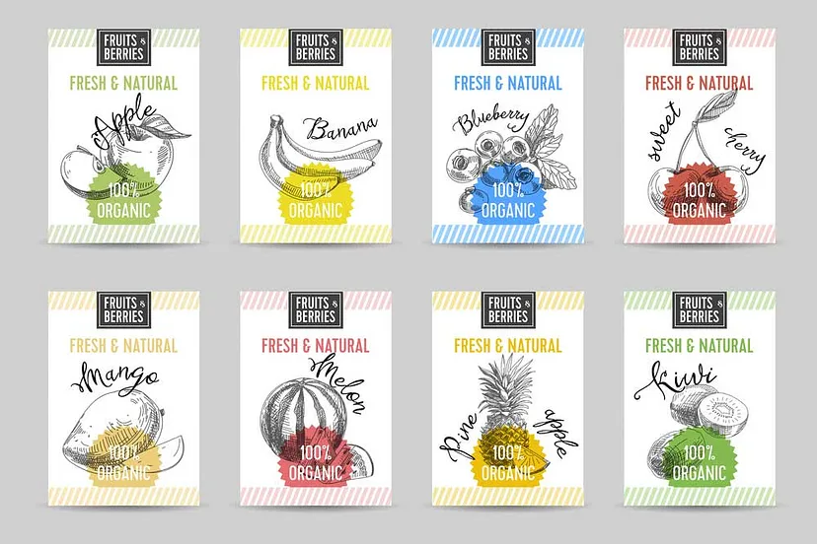
Figure 1.0: Example of color scheme
  - Step Four: The right Typography is Essential
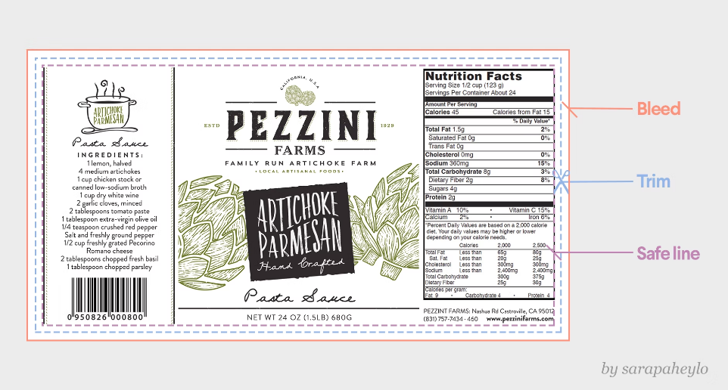
Figure 1.1: Label Template

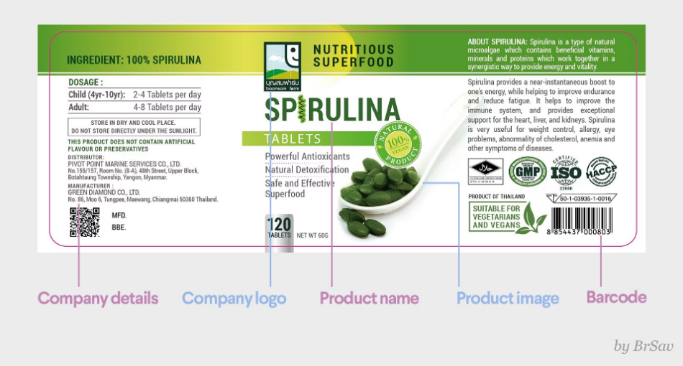
Figure 1.2: Label Layout Template

Ensure you have the following before proceeding with your design:

- The company logo
- Product detail: Check to see if the details provided tell you what the product is, who is likely to buy it, and why. Your client should also tell you if this product is part of a series with an established design style.
- Required file types and dimensions: Some clients will provide this information. If they don't, you could ask to connect directly with the printer.
- Type of packaging: This will help determine whether you need to create a front and back label (eg. cereal box), or a label that runs around (eg. beer bottle).
- The copy (text)
- Branding guidelines: Not all clients have this, but ask if they do, so you can follow guidelines.
- Preferences: Most clients have preferences for the look and feel of the label, from shapes (square, oval, etc.) to colors. Make the most of your design time and get a clear idea from the start.
- Slogan/Tagline Design Process: Generate a list of possible slogans/taglines at the same time you are concentrating on logo marks.
- Combinations or Lockups:
  - When we combine the logo mark with the name of the business or the slogan it is referred to as a “lockup” which includes different combinations of:
- LOGO
- SLOGAN
- NAME
  - TOGETHER, the logo, name and slogan need to complete the entire message of the brand:
    - Type of business
    - Name of business
    - The main characteristic or quality of the business
    - Be a unique, cohesive and memorable visual symbol
Student Example:
https://graphicdesignthoughts.files.wordpress.com/2021/11/logos-colors-02.pdf
https://graphicdesignthoughts.files.wordpress.com/2021/11/logo-lockups-03.pdf
    - The Brand or Visual Identity System: The word “system” is key here. It implies that all the separate parts work together and compliment the whole—a gestalt.
    - Deliverables: From your final three choices, pick one of them and create 3 deliverables for your brand.
- Organization (one submission per group):
  - Printed deliverables:
    - Business logo
    - Prototype with product sticker
    - Slide Presentation
    - Report
  - Digital copy upload in BlackBoard:
    - BusinessLogo.JPEG & PNG
    - ProductSticekr.JPEG & PNG
    - SlidePresentation.PPT
    - Report.PDF
- Formal Presentation: DUE 20th NOVEMBER 2023
  - You have 20 minutes for presentation + 10 minutes for Q&A.
  - Late submission will cause 5 marks deducted per day.
  - Plagiarism will cause ZERO mark. All the works submitted must be original from students.
For the graphic design and documentation respectively. Please also make sure you have a copy of the work as well!

Report Requirements:

Report:

- Cover Page
- Table of Content
- Introduction Explain about your business introduction, aim and objectives.
- Content Follow the ‘GUIDELINE’, You must document all the steps, put all the design process or any pictures and screenshot involved in the process. [at least 5 pages]
- Conclusion Summarize what you have learnt in this project. [each members must have a paragraph of what you have learnt in this project]
- References Follow format given.
- Appendix i Business Logo
- Appendix ii Product Sticker
- Rubric (compulsory to attach at the end of the page)

Slide Presentation:

- Slide 1: Business name, Slogan/ Tagline, Team members name and studentID
- Slide 2: Introduction
- Slide 3: Business Aim
- Slide 4: Business Objective
- Slide 5: Target customers and target area
- Slide 6: Moodboard
- Slide 7: Logo Design Process
- Slide 8: Product Sticker Design Process
- Slide 9: Tagline Design Process
- Slide 10: Final Logo
- Slide 11: Final Product Sticker
- Slide 12: Final Tagline
- Slide 13: Feedback / What you have learnt in this project
- Slide 14: Conclusion

Format for writing report

- Your report should be typed, 1.5-spaced on standard-sized A4 paper with margins of 1 inch on all sides. Your final report should include, in the order indicated below.

- Introduction (bold, uppercase, font size 12)
- Content (bold, uppercase, font size 12)
- Conclusion (bold, uppercase, font size 12)
4.0 References (bold, uppercase, font size 12)

- The pages of your report should be numbered consecutively, at the bottom centered of the page.
- Report font type: Arial, Calibri, Century Gothic or Verdana.
- Report font size: 12
- Minimum pages: 3 pages excluding references and cover page

References format:

- Author name. (year). Article title. Retrieved date, from URL address

sample
- Microsoft. (2012). How to Prevent and Remove Viruses and other Malware. Retrieved September 25, 2012, from http://support.microsoft.com/kb/129972.



RUBRIC FOR GROUP PROJECT
Course Name: | Student’s Name:  1.  2. | Lecturer’s Name:
Course Code: | Student’s ID: | Class: OC

Criteria | Marks  Allocated | 1 | 2 | 3 | 4 | 5 | Marks Obtained
REPORT
Analytical skills | 5 | Not able to analyse the given task | Minimal ability to analyse the given task | Some ability to analyse the given task | Able to analyse with good illustration | Able to analyse with good illustration | x1
Writing skills  - Content | 10 | The content was minimally relevant to the given task | The content was quite relevant to the given task | The content was relevant to the given task | The content was highly relevant to the given task | The content was highly relevant and interesting | x2
- Organization | 10 | The paper was poorly organized and lacked supporting evidence. Generalization was a problem | The paper was weak, and support was insubstantial or unconvincing | The organization of paper was good and generally supports with little evidence | The organization of paper was well organize and supports with evidence | The paper was extremely well organize through the use of examples in details | x2
- Language | 5 | Writing lacks sentence variety | Sentences were somewhat varied and some were inappropriate | Sentences were correctly constructed | Sentences were correctly constructed and well-articulated | Sentences were well written and expressed | x1
Knowledge skills | 5 | Student demonstrated some grasp of the subject knowledge | Student demonstrate moderate level of the subject knowledge | Student demonstrate sufficient level of the subjects’ knowledge | Student demonstrate sound subjects’ knowledge | Student demonstrate excellent subject knowledge | x1
Grammar | 5 | Too many grammatically errors | Numerous grammatical errors | Several grammatical errors | Few grammatical errors | No grammatical errors | x1
GRAPHIC DESIGN & OUTPUT
Problem Solving | 10 | Investigate: little or no media collected; no goal articulated  Plan: little or no evidence of planning  Explore & Develop: project shows little or no exploration. | Investigate: minimal media collected; not well related to goal  Plan: minimal planning; multiple parts missing and unclear  Explore & Develop: minimal or no sketching nor explorations; no use of elements nor principals of design | Investigate: some media collected; some relationship to goal  Plan: audience nebulous; goal present but unclear; explanation missing Explore & Develop: some evidence of initial sketching; minimal evidence of principals of design; one or two elements used effectively | Investigate: various media collected; related to goal  Plan: audience defined; goal reasonably clear; some explanation Explore & Develop: several exploratory sketches; product shows application of one or more principles of design; used one or more elements effectively | Investigate: various media collected; related to goal  Plan: audience defined; goal reasonably clear; some explanation  Explore & Develop: several exploratory sketches; product shows application of one or more principles of design; used one or more elements effectively. | x2
Program Execution | 20 | Final Piece: project showed no evidence of original thought; clearly copied substantially or wholly | Final Piece: project fulfilled the assignment, but gave no evidence of trying anything unusual; some or all of the work may have been copied | Final Piece: one or very few ideas were tried, but lacked originality; substituted "symbols" for personal observation | Final Piece: a few ideas were tried before selecting one; showed limited use of unusual combinations or connections; made decisions after referring to one source; solved the problem in a logical way | Final Piece: several choices were explored before selecting one; unusual combinations tried on several ideas; made connections to previous knowledge; demonstrated understanding of problem solving skills | x4
Design and Output | 10 | Work overall is disjointed because of a lack of common elements. | The design project  is distractingly.  cluttered or  devoid of necessary  elements and  very poorly  designed. It is not  attractive. | The design project is acceptably attractive though it may be a bit disorganized and  does not demonstrate.  a clear understanding  of layout:  dominance, size,  rhythm, balance,  etc | The design project.  is attractive in terms. of design, layout  and neatness and  demonstrate an  understanding of  the use of design  tools. | The design project.  is exceptionally.  attractive in terms  of design, layout,  neatness, dominance,  rhythm, size,  etc. | x2
Documentation | 10 | Font choices and/or effects create distractions. | Font choices and/or effects create distractions. | Typography is generally effective, although font choice, size and effects may create minor distractions. | Typography choices are appropriate without an excessive number of fonts or effects. | Fonts and effects help to create a strong verbal-visual connection within the work. All font sizes are appropriate. | x2
Assessment & Reflection | 10 | Evaluation: no effort to keep any work-in- progress, take notes, nor draw conclusions Reflection: offered no realistic nor relevant suggestions for improvement | Evaluation: very few or no drafts, models or sketches kept; few or no process notes taken; a conclusion may have been offered but isn’t related nor supported Reflection: one suggestion for improvement was offered; was unrealistic, inaccurate, and/or misguided | Evaluation: few drafts, models and sketches kept; process notes may have been taken; a conclusion is presented but isn’t supported Reflection: few suggestions for improvement offered; suggestions were: unrealistic or inaccurate or misguided | Evaluation: some drafts, models & sketches were kept; some process notes were kept; a reasonable conclusion presented and somewhat supported with evidence Reflection: some suggestions for improvement were offered and were 1 or more of realistic, accurate and insightful | Evaluation: all process sketches, drafts and models were kept; notes of the process were taken; valid conclusion(s) presented, related directly to the plan and goal; evidence clearly supports conclusion  Reflection: several suggestions for improvement presented; suggestions were realistic, accurate and insightful | x2
Overall Assessment | 100

COMMENT:

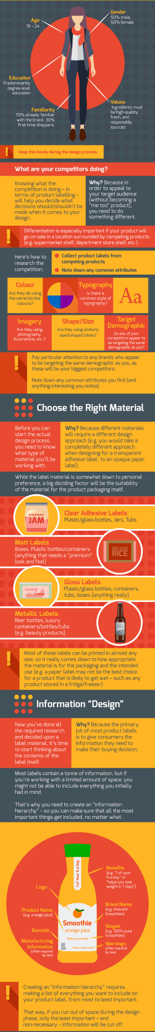
DESIGN
GUIDELINES
POSTER

